

Topic test 1
Name: __________________________________

Chapter 2: Linear models for numerical data

- Time allowed: 45 minutes
- CAS calculators may be used.
- Part A: 10 multiple-choice questions (10 marks)
- Part B: 4 short-answer questions (29 marks)
- Part C: 1 analysis question (11 marks)
Part A
Multiple-choice questions
10 multiple-choice questions
1 mark each: 10 marks
Circle the correct answer.
1 Which of the following scatter plots has a linear relationship?
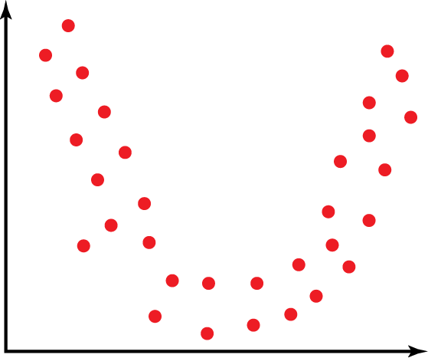  A | 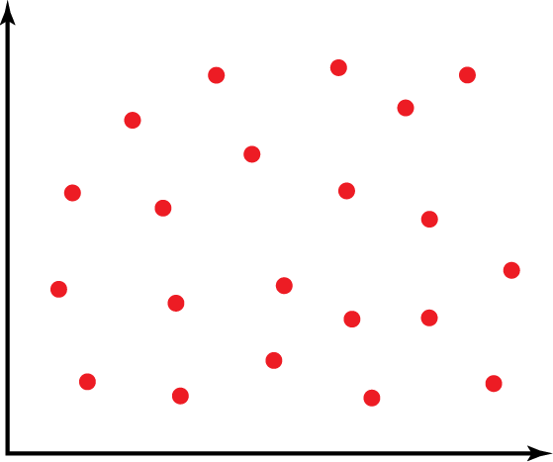  B | 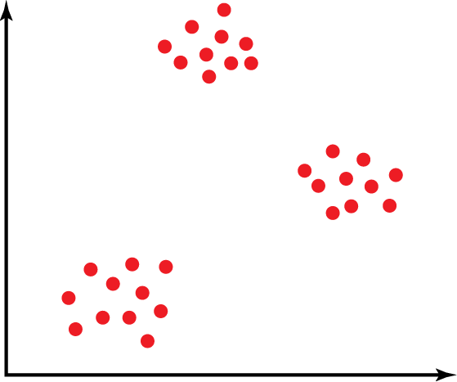  C
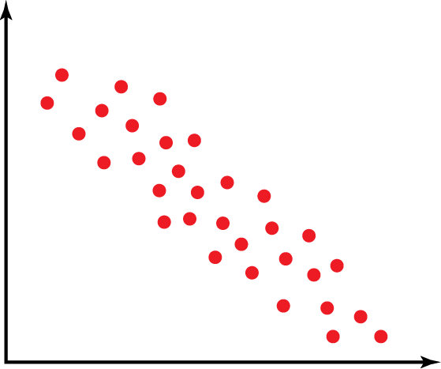  D | E None

[1 mark]
2 Pearson’s correlation coefficient is a measure of the strength of the relationship between two variables and must vary between the values:
A  1 to 0
B 0 to 1
C 1 to 1
D 10 to 10
E None of the above

[1 mark]
The following information relates to Questions 3, 4 and 5.
The following least-squares regression line models data collected about the height (metres) of trees and the number of years they have been planted.
Height = 0.9 + 1.2 × Years planted
3 The predicted height of a tree that has been planted for 5 years is:
A 6 metres
B 6.4 metres
C 6.9 metres
D 720 centimetres
E 600 centimetres

[1 mark]
4 Which one of the following statements is false?
A When planted, a tree is 0.9 metres tall.
B The height of a tree increases as the years it has been planted increase.
C There is a positive correlation between height and years planted.
D The height of a tree decreases by 1.2 metres for every 1 year it increases in age.
E The height of a tree depends on the number of years it has been planted.

[1 mark]
5 A tree that had been planted for 10 years measured 12.1 metres tall. The residual value for a tree that has been planted for 10 years is:
A 0.8 metres
B  0.8 metres
C 1 metre
D 1 metre
E None of the above

[1 mark]
The following information relates to Questions 6, 7 and 8.
A class of students sat for a Biology test as well as a Chemistry test. The scatter plot below displays the results with the regression model fitted.
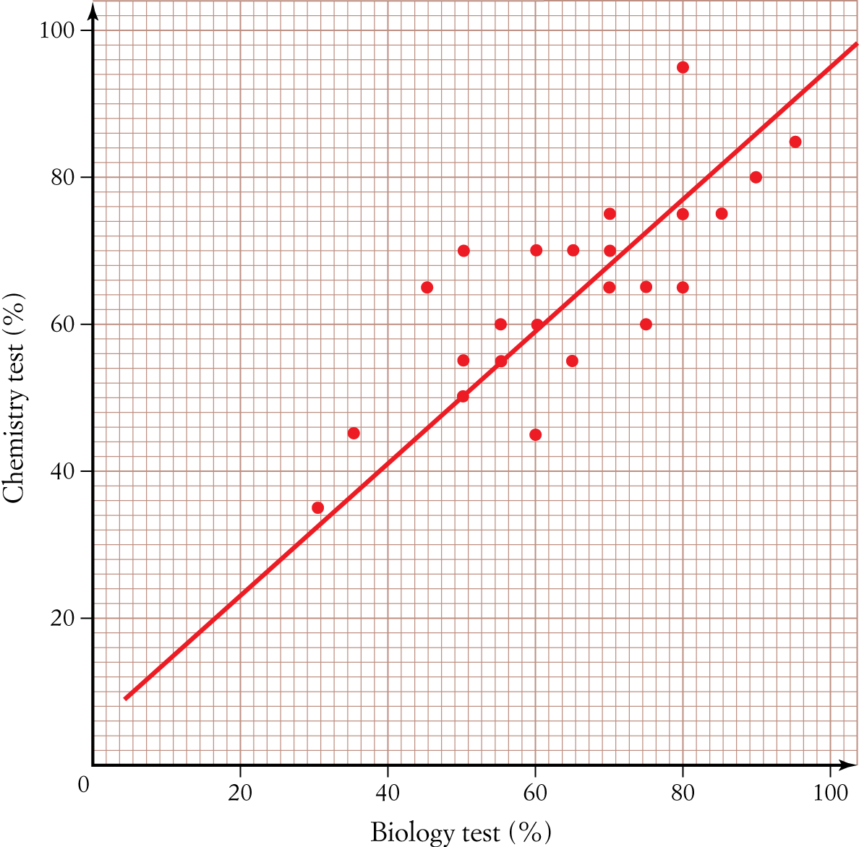

6 If a residual plot was constructed for these data it would have:
A Ten negative residual values
B Five residual values of 0
C Fifteen positive residual values
D All positive residuals
E All negative residuals

[1 mark]
7 If 65% of the variation in the Chemistry test result can be explained by the variation in the Biology test result, then the correlation coefficient will be closest to:
A 0.80
B 0.80
C 1
D 0.81
E 0.81

[1 mark]
8 The regression line was used to predict the Chemistry test result for a student who received 20% for their Biology test result. Which one of the following statements is true?
A The prediction will be that the Chemistry test result will be approximately 80%.
B The prediction will be reliable, as it is an example of interpolation.
C The prediction will be reliable, as it is an example of extrapolation.
D The prediction will not be reliable, as it is an example of extrapolation.
E The prediction will not be reliable, as it is an example of interpolation.

[1 mark]
9 If r = 0.74, then r2 is equal to:
A 0.86
B 0.86
C 0.55
D 0.55
E 0.25

[1 mark]
10
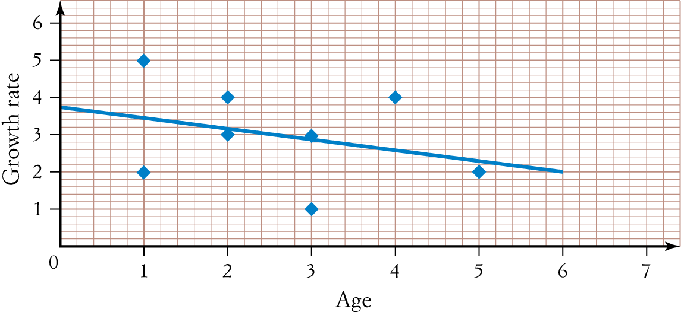

The plot of the residuals against Age is closest to:
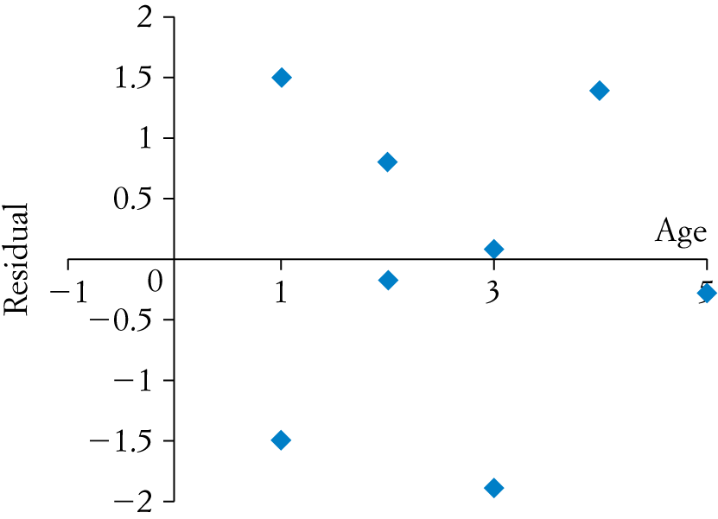  A | 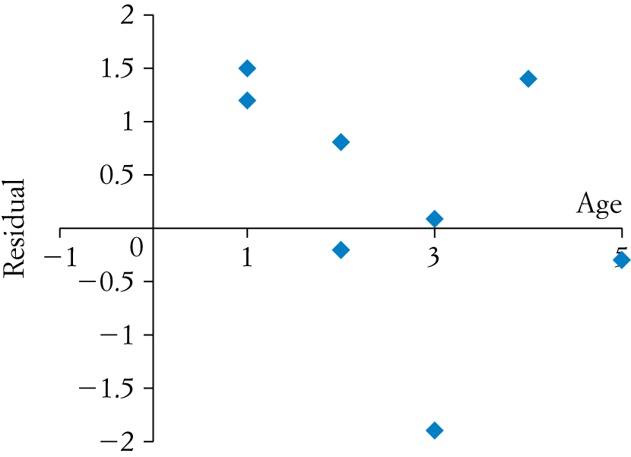  B
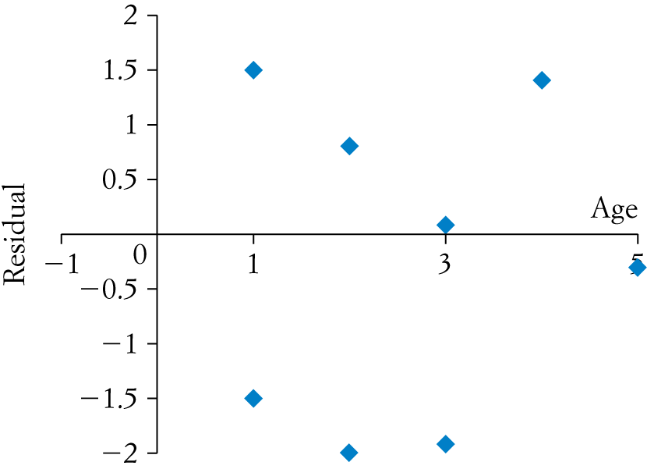  C | 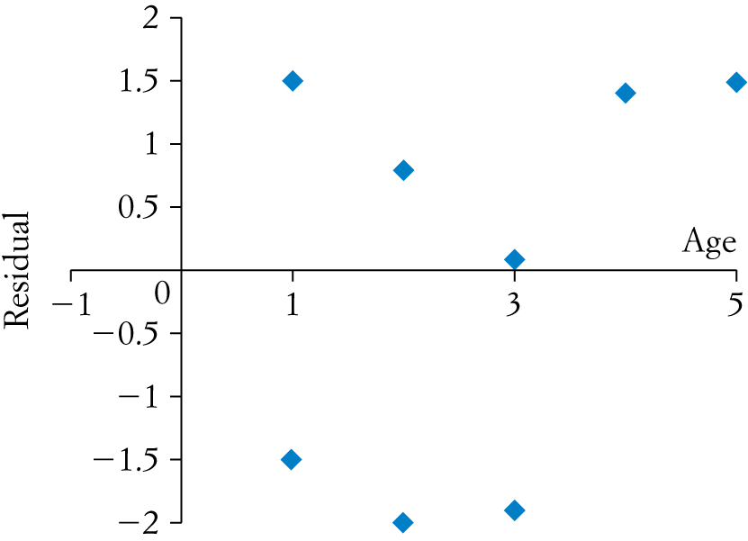  D
E
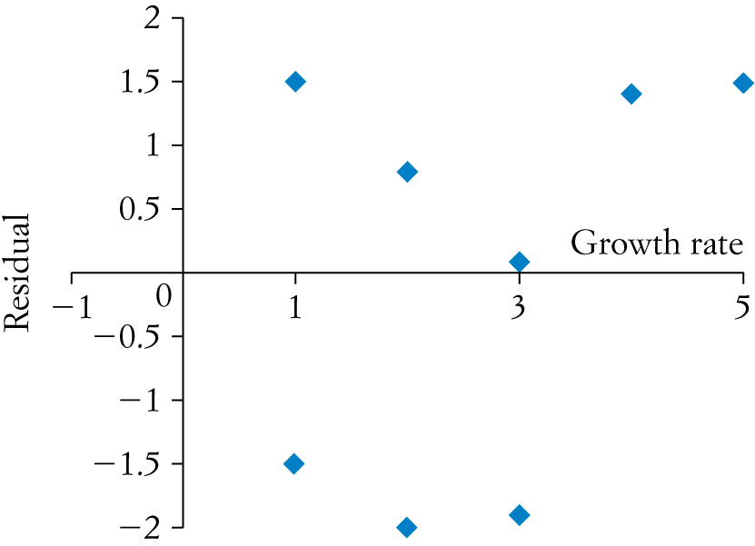

[1 mark]
Part B
Short-answer questions
4 short-answer questions
29 marks
Show your working where appropriate.
1 Data was collected to investigate whether a person’s income ($) depends on their height (cm) and is displayed in the table below. State all answers correct to two decimal places.
Height (cm) | 174 | 162 | 165 | 183 | 185 | 158 | 176 | 196
Income ($) | 62 000 | 36 000 | 44 000 | 51 000 | 60 000 | 47 000 | 39 000 | 26 000
a Using CAS, calculate the least-squares regression line that models the data.

b Calculate and interpret Pearson’s correlation coefficient for the data.

c Calculate and interpret the coefficient of determination for the data.

d Is the regression line found in part a an appropriate linear model? Justify your answer.

[9 marks]
The following information relates to Questions 2 and 3.
A group of 25 year olds were surveyed regarding the number of hours spent exercising per week and their resting heart rate (beats per minute). The data collected for the number of hours of exercise per week ranged from 0 hours to 6 hours.
The regression line that models the data was found to be:
Resting heart rate = 63  0.96 × Exercise, with a correlation coefficient of 0.52.

2 Use the information above to complete the following sentences.
a A person’s resting heart rate will be ________ beats per minute when the amount of ___________ is
0 hours per week.
b ___________ of the variation in _______________ can be explained by the variation in the amount
of _______________.
c A person’s resting heart rate will _______________ by _______ beats per minute for every one hour increase in exercise.
[7 marks]
3 Use the regression line to:
a Predict the resting heart rate for a person who exercises for 3 hours per week. Is this prediction classified as interpolation or extrapolation? State answer correct to one decimal place.

b Predict the amount of exercise required per week for a person with a resting heart rate of 55 beats per minute. Is this prediction classified as interpolation or extrapolation? State answer correct to one decimal place.

c Which of the above predictions is the most reliable? Justify your answer.

[6 marks]
4 The weights (kg) of 13-year-old students (y) and the number of chocolate bars consumed per week (x) were recorded and the values of the following statistics were determined.
= 3.23 = 1.6 = 41.55 = 5.61 r = 0.56
a Calculate the least-squares regression line that models these data, stating all coefficients correct to two decimal places.

b Use the regression line to predict the weight of a 13-year-old student who eats 5 chocolate bars per week, correct to two decimal places.

c Hence, calculate the residual value for Peter who weighs 43 kg and eats 5 chocolate bars per week.

[7 marks]
Part C
Analysis question
1 analysis question
11 marks
Show your working where appropriate.
1 Data was collected from a rugby team to investigate whether there is a relationship between a player’s weight (kg) and their chest size (cm). The results are displayed in the table below.
Weight | 70 | 75 | 80 | 81 | 85 | 87 | 90 | 91 | 95 | 101 | 102 | 105 | 115 | 120
Chest size | 79 | 75 | 85 | 80 | 86 | 90 | 97 | 92 | 98 | 100 | 99 | 103 | 102 | 123
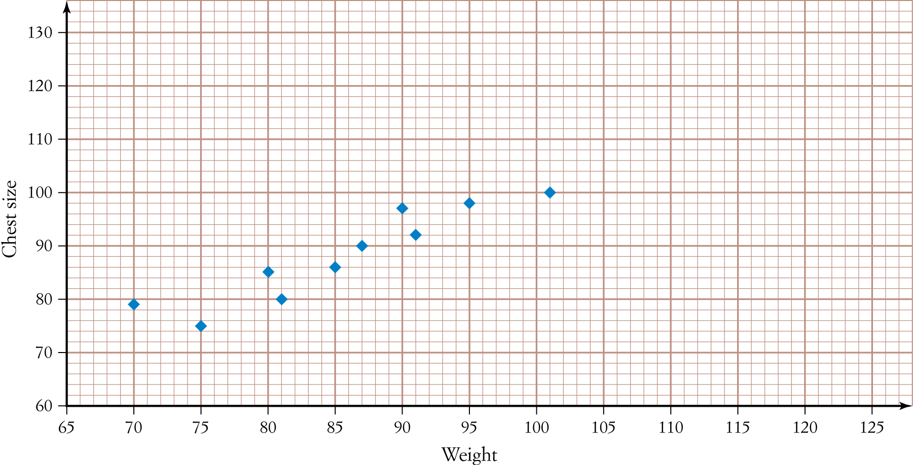
a Add the last four data points from the table (in bold) to the scatter plot below.
b Calculate the least-squares regression line that models the data, stating all coefficients correct to two decimal places.

c Hence, sketch the regression line onto the scatter plot in part a.

d Calculate all the residual values (to one decimal place) for the data and complete the table below.

Weight | 70 | 75 | 80 | 81 | 85 | 87 | 90 | 91 | 95 | 101 | 102 | 105 | 115 | 120
Residual | 3.6 |  |  | 24.2 |  |  | 5.6 |  |  | 20.2 |  |  | 29.3 | 7.7

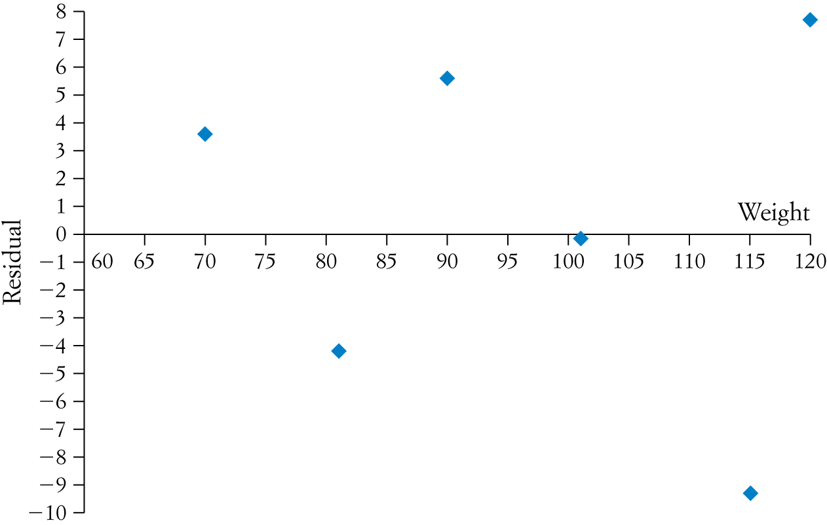
e Hence, complete the residual plot below.
f Using the residual plot, justify whether the regression model found in part b is appropriate.

[11 marks]
[Total marks: 50]

Answers
Part A – Multiple-choice questions [1 mark each]
1 Linear relationship indicates that dots form a straight line.
∴ D
2 Pearson’s correlation coefficient is a numerical value that ranges between 1 and 1.
∴ C
3 Height = 0.9 + 1.2 × Years planted
Height = 0.9 + 1.2 × 5
= 6.9 metres
∴ C
4 A True, as y-intercept is 0.9, which occurs when years planted is 0.
B True, as the regression line has a positive gradient, so both variables increase.
C True, as the regression line has a positive gradient; therefore, a positive correlation.
D False, as the sentence should read ‘increases’ rather than ‘decreases’ due to positive gradient.
E True, as height is the y variable.
∴ D
5 Height = 0.9 + 1.2 × Years planted
Predicted height = 0.9 + 1.2 × 10
= 12.9 metres
Residual value = actual value – predicted value
= 12.1  12.9
= 0.8 metres
∴ B
6 Points above the regression line will have a positive residual, points below the regression line will have a negative residual and points on the regression line will have a residual of 0. There are 10 points below the regression line.
∴ A
7 r2 = 0.65
r = 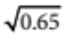
=  0.81
As the gradient and direction of the line are positive, r = 0.81.
∴ E
8 A False, as when reading from scatter plot, a Biology score of 20% predicts a Chemistry score of
approximately 23%.
B False, as the prediction is outside the data range provided; therefore, not interpolation.
C False, as extrapolation is not reliable.
D True, as the prediction is outside the data range provided; therefore, extrapolation, which is not reliable.
E False, as interpolation is reliable.
∴ D
9 r = 0.74
r2 = (0.74)2
= 0.55
∴ C
10 A Residual order is correct, as it is alternating between positive and negative, and distances from x-axis are
correct.
B First two residuals are positive when one should be negative.
C Second negative residual is too far below the x -axis.
D Last residual is positive, but it should be negative.
E The x -axis is labeled with an incorrect variable.
∴ A
Part B – Short-answer questions
1 a Using CAS, regression line is:
Income = 65 197.34 – 111.92 × Height
[1 mark for 65 197.30]
[1 mark for 2111.92]
[1 mark for correct variable names]
b r = 0.12 [1 mark], which indicates there is no relationship [1 mark] between income and height.
c r2 = 0.01 [1 mark]. 1% of the variation in income can be explained by the variation in height [1 mark].
d No, not an appropriate model [1 mark] as:
- there is no relationship between the variables OR
- 99% of the variation in income is not explained by the variation in height OR
- low r and r2 values.
[1 mark for any one of the reasons above]
2 a A person’s resting heart rate will be __63__ beats per minute when the amount of ___exercise___ is
0 hours per week.
b __27%__ of the variation in _resting heart rate__ can be explained by the variation in the amount of __ exercise _.
c A person’s resting heart rate will _decrease_ by _0.96_ beats per minute for every one hour increase in exercise.
[1 mark for each correct answer]
3 a Resting heart rate = 63  0.96 × 3
= 60.1 beats per minute [1 mark]
Interpolation [1 mark]
b 55 = 63  0.96 × Exercise
Exercise = 8.3 hours [1 mark]
Extrapolation [1 mark]
c Prediction for 3 hours is the most reliable [1 mark], as it is interpolation [1 mark].
4 a 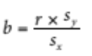 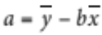
= 41.55  1.96 × 3.23
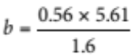 = 35.22 [1 mark]
= 1.96 [1 mark]
Weight = 35.22 + 1.96 × Number of chocolate bars [1 mark for correct equation]
b Weight = 35.22 + 1.96 × 5 [1 mark]
= 45.02 kg [1 mark]
c Residual = Actual – Predicted
= 43  45.02 [1 mark]
= 2.02 kg [1 mark]
Part C – Analysis question
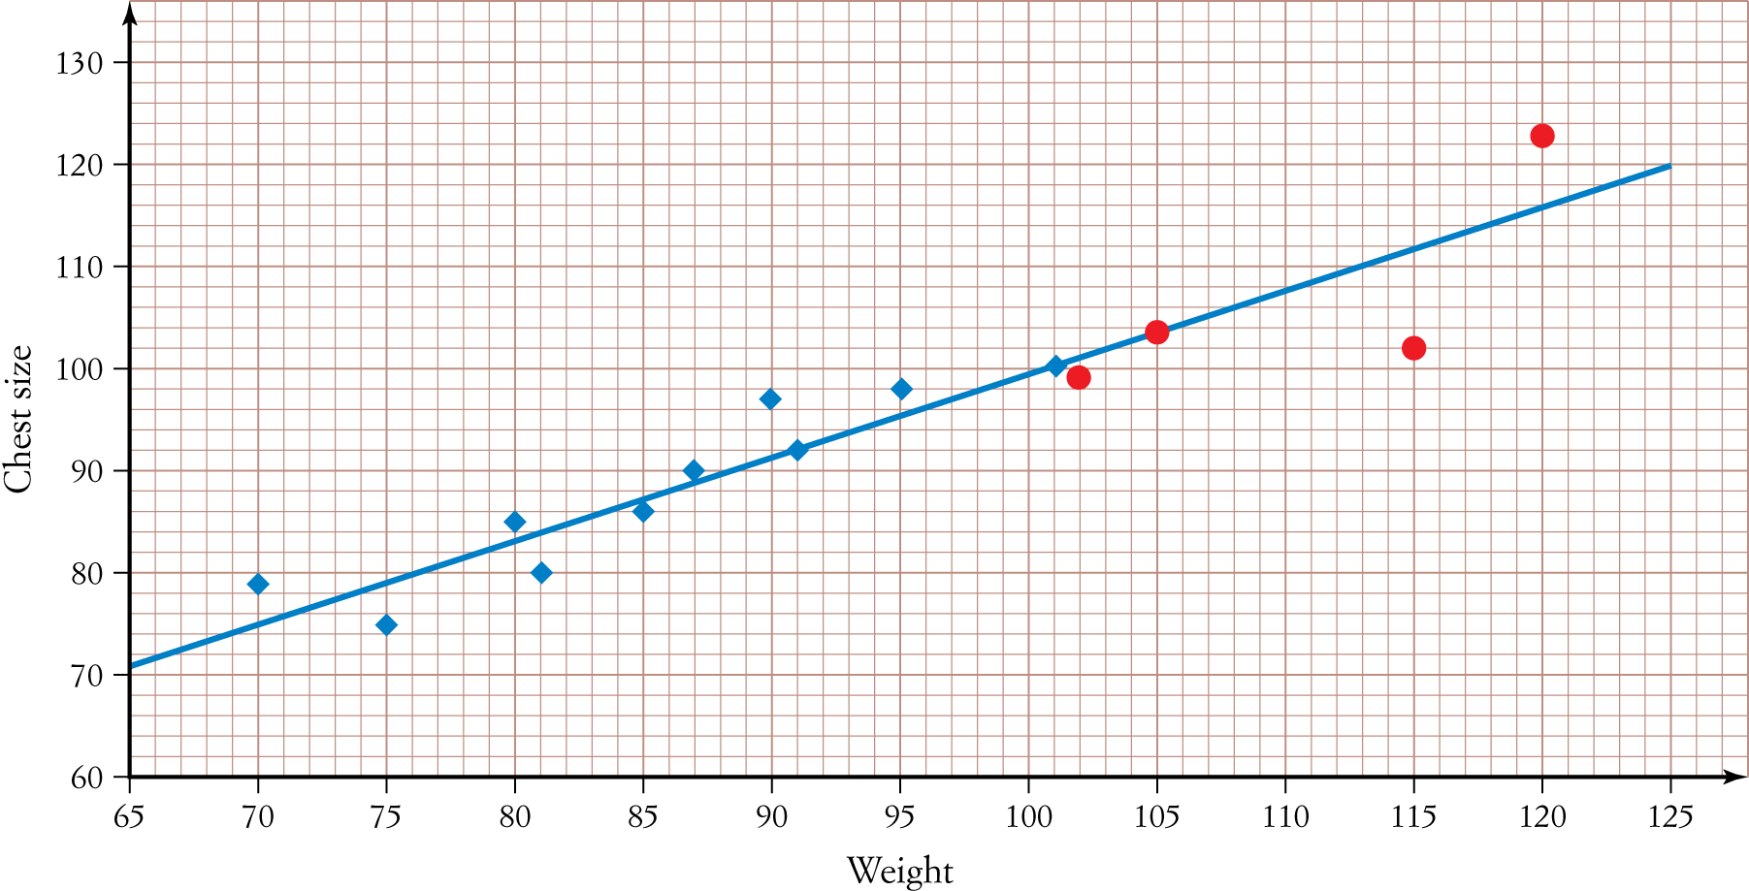
1 a
[2 marks 2 0.5 marks for each of the extra points added]
b Chest size = 19.59 + 0.80 × Weight [2 marks for all correct, 21 mark if a value is wrong or variable names are incorrect]
c See scatter plot in part a. [2 marks] + check the value to make sure it crosses the y-axis and another set of correct coordinates for the equation previously stated. Students may select different x values to substitute into the equation. Therefore, these will need to be checked by the teacher according to the equation students have found.
Weight | 70 | 75 | 80 | 81 | 85 | 87 | 90 | 91 | 95 | 101 | 102 | 105 | 115 | 120
Residual | 3.6 |  4.4 | 1.6 | 4.2 | 1.4 | 1.0 | 5.6 | 0.2 | 2.6 | 0.2 | 2.0 | 0.4 | 9.3 | 7.7
d

[2 marks for all correct, 1 mark if three points are correct]
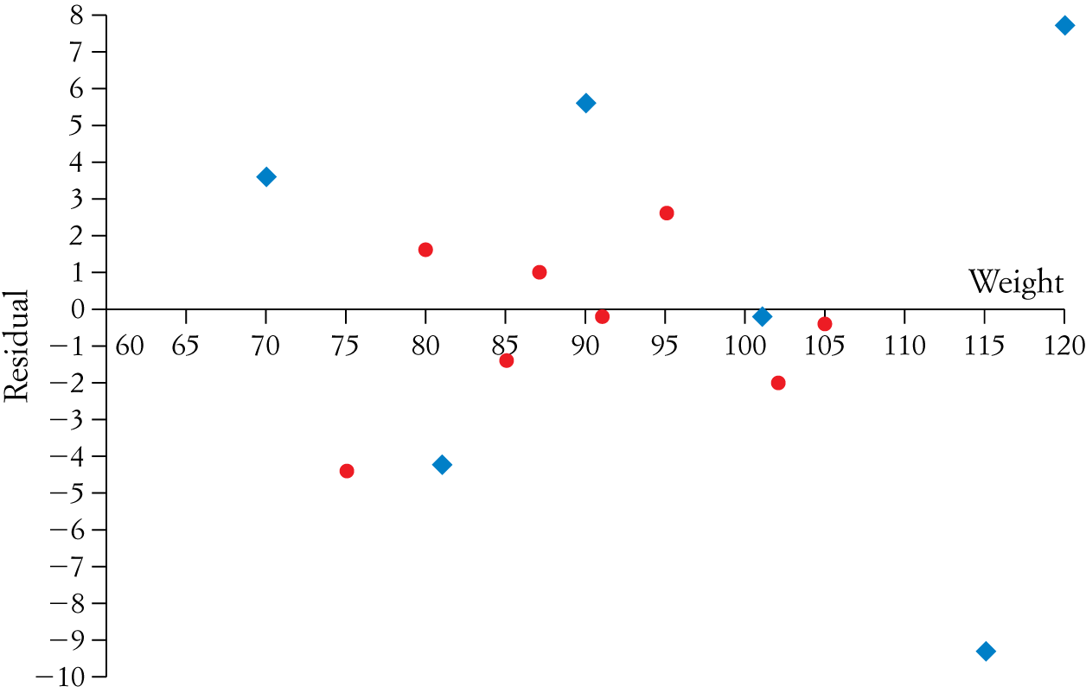
e
[2 marks if all points added are correct and 1 mark if three points are added correctly]
f Yes, as the points in the residual plot are randomly scattered above and below the x-axis; therefore, the data is probably linear. [1 mark]

